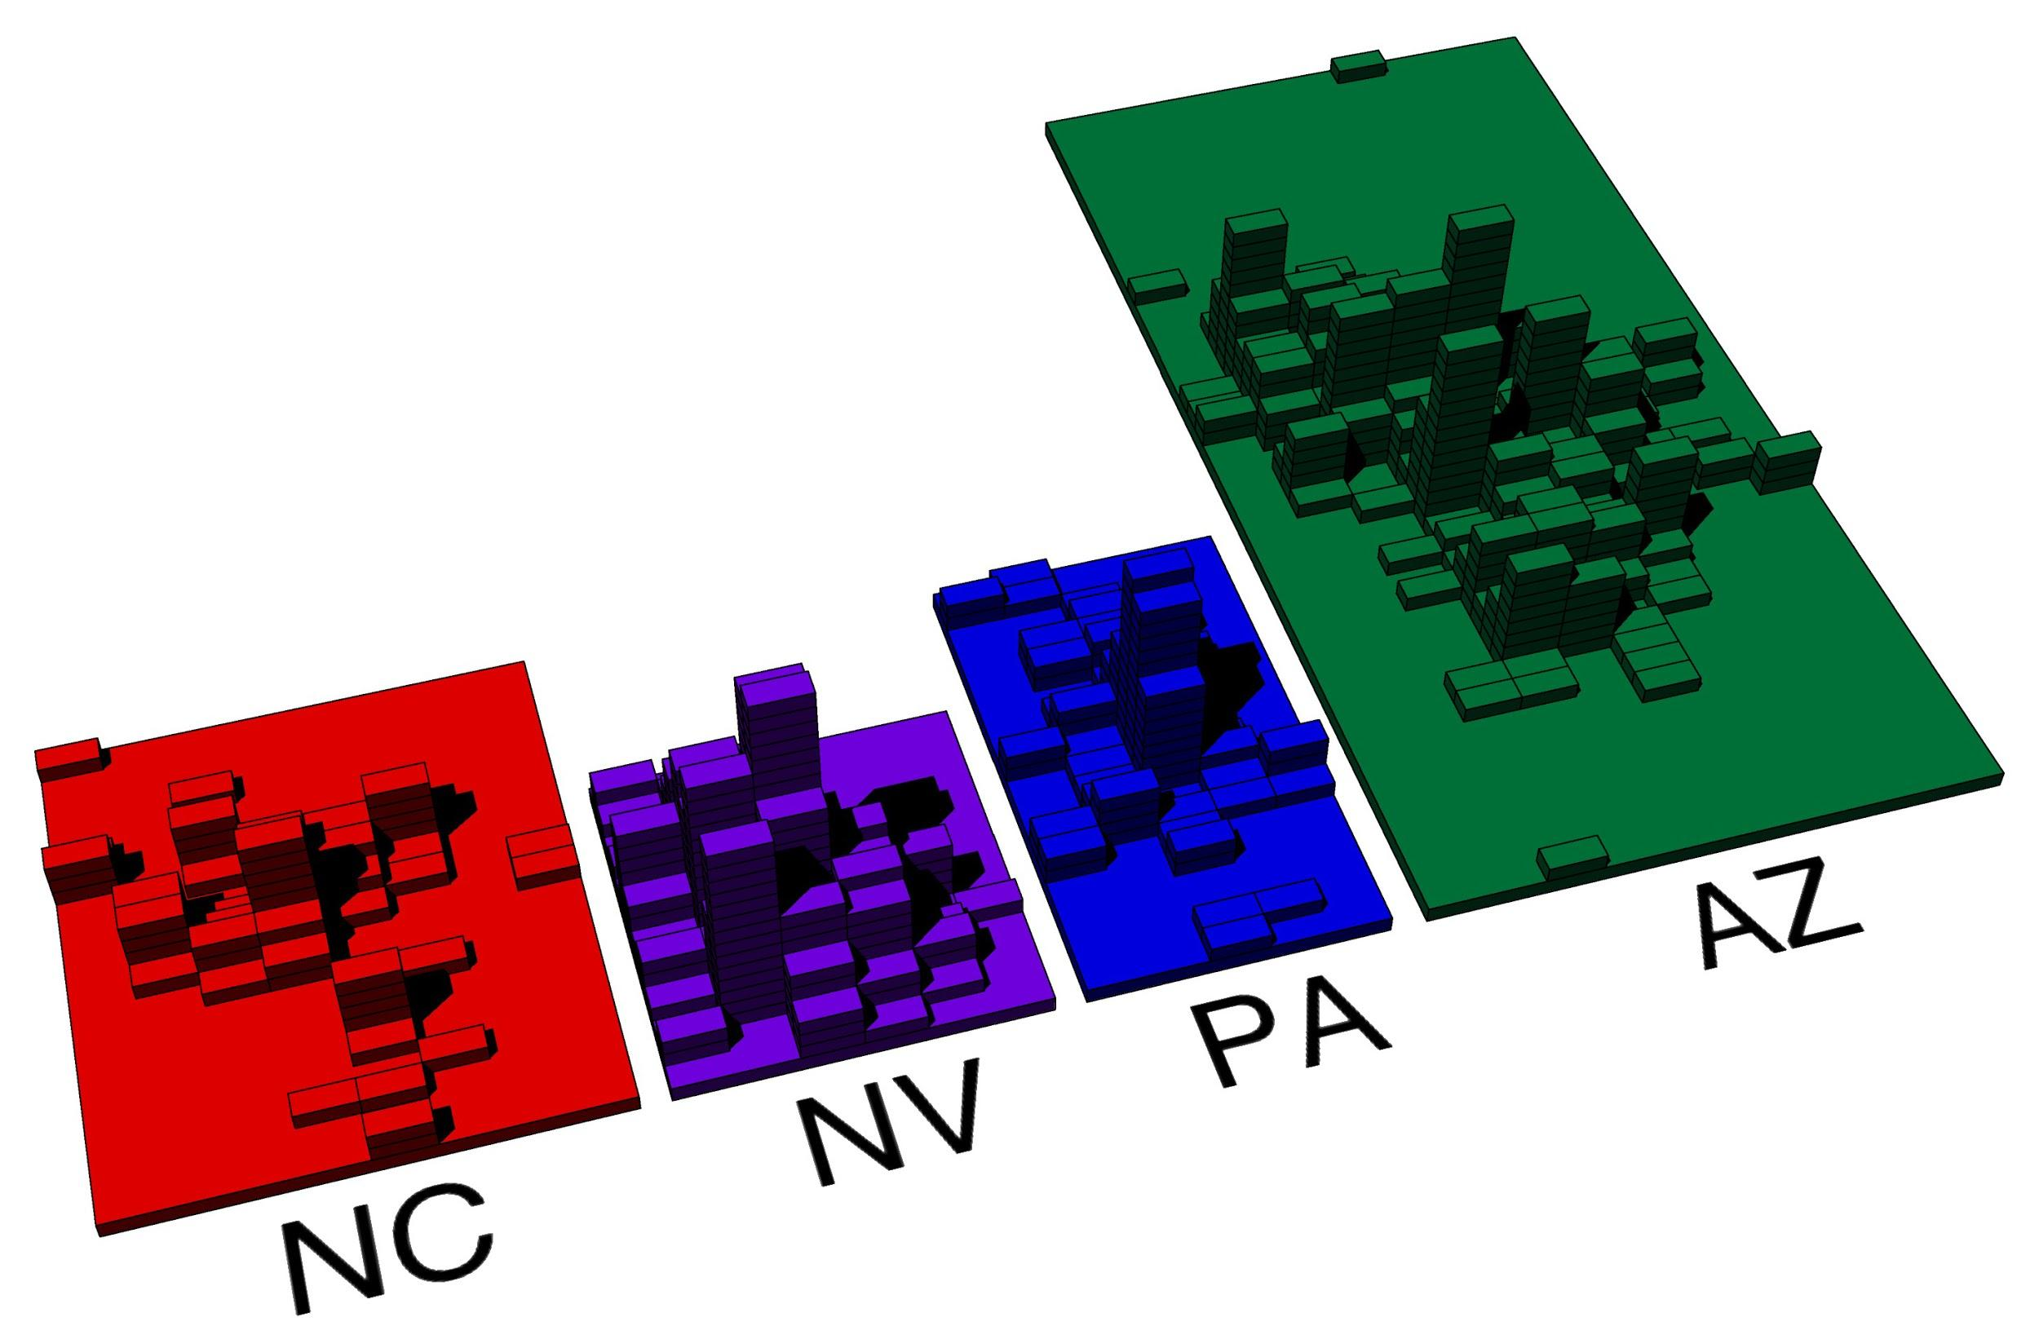

This script takes a file containing yelp data for a variety of businesses and creates points from the latitude and longitude of the buisnesses with the state abbriviation inputed. It then creates a grid of brick sized rectangles encompasing all the points, and counts the number of points in each brick footprint and places that many bricks on that spot, showing the density of businesses in each state.

Due to the incompleteness of the dataset used, most states seem to have a limited selection of buisnesses, mostly located within a single metropolitain area. However, any dataset with location data could be used.